Project name:
Learning by using Audio and Video

Members:
- Eman AbdEllah
- Heidi Sayed
- Hind Mohammed
- Noura Shaban
- Shimaa Omar

Description:
-Our project aims to help beginners in learning asp.NET.
- We will use audio and video in the project to facilitate the learning process.
-The idea of the project is as same as the idea of video tutorials that exists in most sites of learning:
1- We will create a media player program that plays audio and video.
2-We will create video tutorials which contains streaming objects with audio that explains the tutorials, or we will search for a ready one.

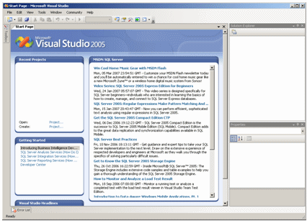
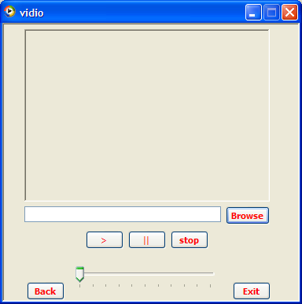

Functions:
-The work in our project is divided into two parts meaningly, two groups. The members of the first group are responsible for audio settings (Sound effects and operations like play, stop, pause, etc…). The members of this group are:
1-Heidi Sayed
2-Noura Shaba
3-Shimaa Omar

-On the other hand, the members of the second group are responsible for video settings and the animation of slides’ elements. The members of this group are:
1-Eman AbdEllah
2-Hind Mohammed

Tools:
We may use C# or Visual Basic or ready code.

